Summary Micheyl et al + stat model Steele

- repeating [ABA_] triplets (van Noorden, 1975).
- manipulated frequency differences (dF) between A and B tone to measure effects on buildup
- psychometric function for humans at 4 dFs
- neurophysiological recordings with macaques for triplets with A at BF for the cell and B matched to one of the dF's used in human experiments
- 10 s trial, 20 repetitions of each dF sequence
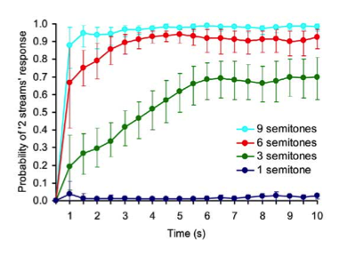
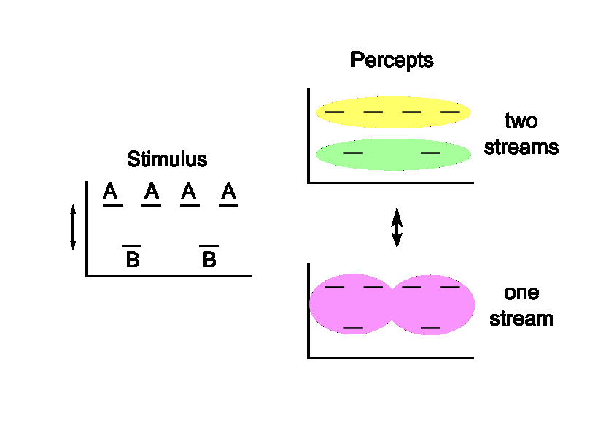
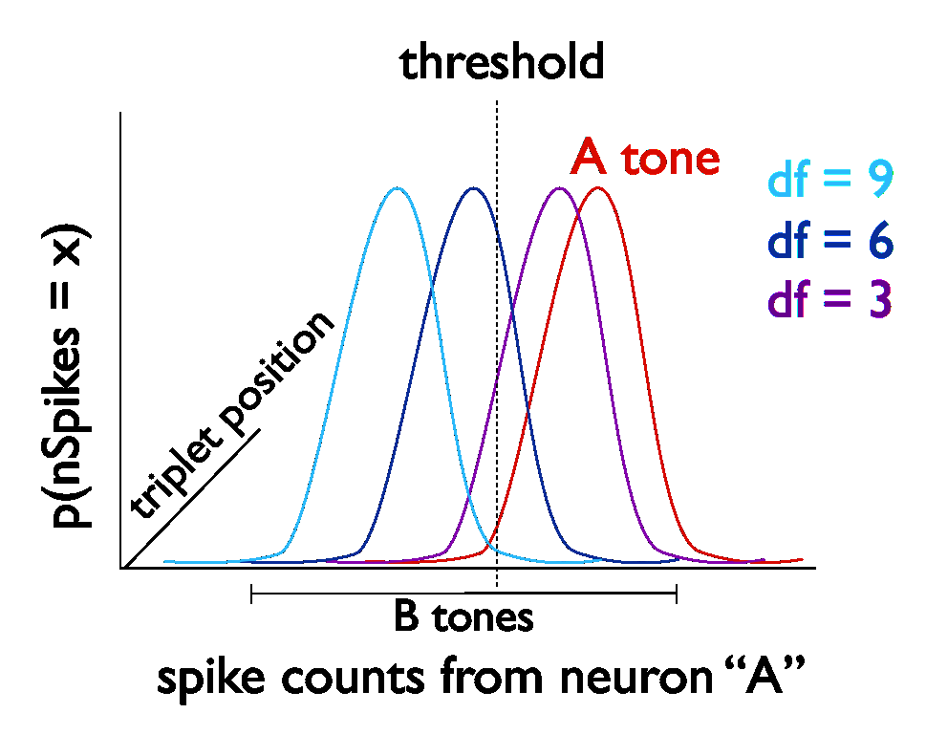
Neurometric function- SDT:

- constructed PSTHs for each tone within each triplet for each triplet position in the sequence
- turn PSTHs for each unit, triplet position and tone into pdf's by dividing by total spike #
- convolve pdf's from each unit together for each triplet position and tone
- Fit one parameter- independent of dF or triplet position/time-- as the “threshold”
- area under pdf to the right of the threshold gives probability that a particular tone at a particular position is detected by the unit tuned to the A tone.
- p(seg) is area under B tone curve to the left of the threshold over area of A tone curve to the right of the threshold. These curves are different for each tone/triplet position

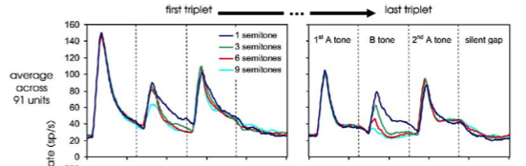
- Because spike counts reliably decrease with distance from the recorded cell's best frequency (selectivity, forward suppression of B tones) and overall with triplet position (habituation), this model will detect a smaller proportion of B tones as dF increases and also with triplet position → stream segregation
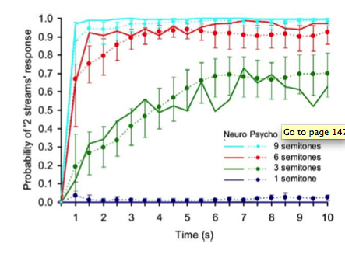

- this model is the equivalent of a signal detection theory frequency discriminator
- similar physiology seen in CN, which is not thought to directly vary with perception.
- doesn't account for percept longevity or for alternations seen with long trials

ALTERNATING RENEWAL PROCESS (ARP) MODEL
- describes a system which alternates between two states, with durations determined by alternating draws from two independent distributions. The first state is known.
- the buildup towards steady state probability from the onset of activity is known as a closed form function of duration distributions.
- We measured alternations with long (4 min) trials, and constructed empirical buildup functions using switch triggered averaging.
- Switch triggered average- the time course from one trial is averaged with multiple copies of itself, aligned to each switch from a segregated percept into integrated percept.
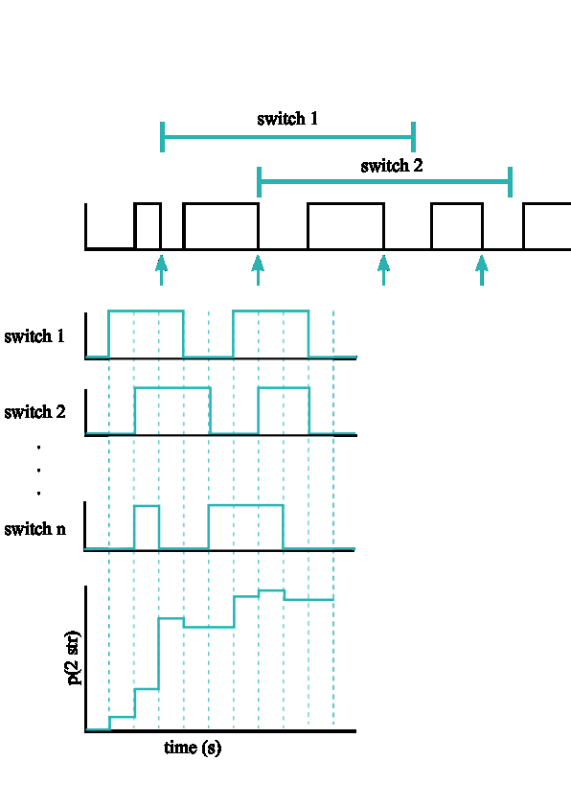
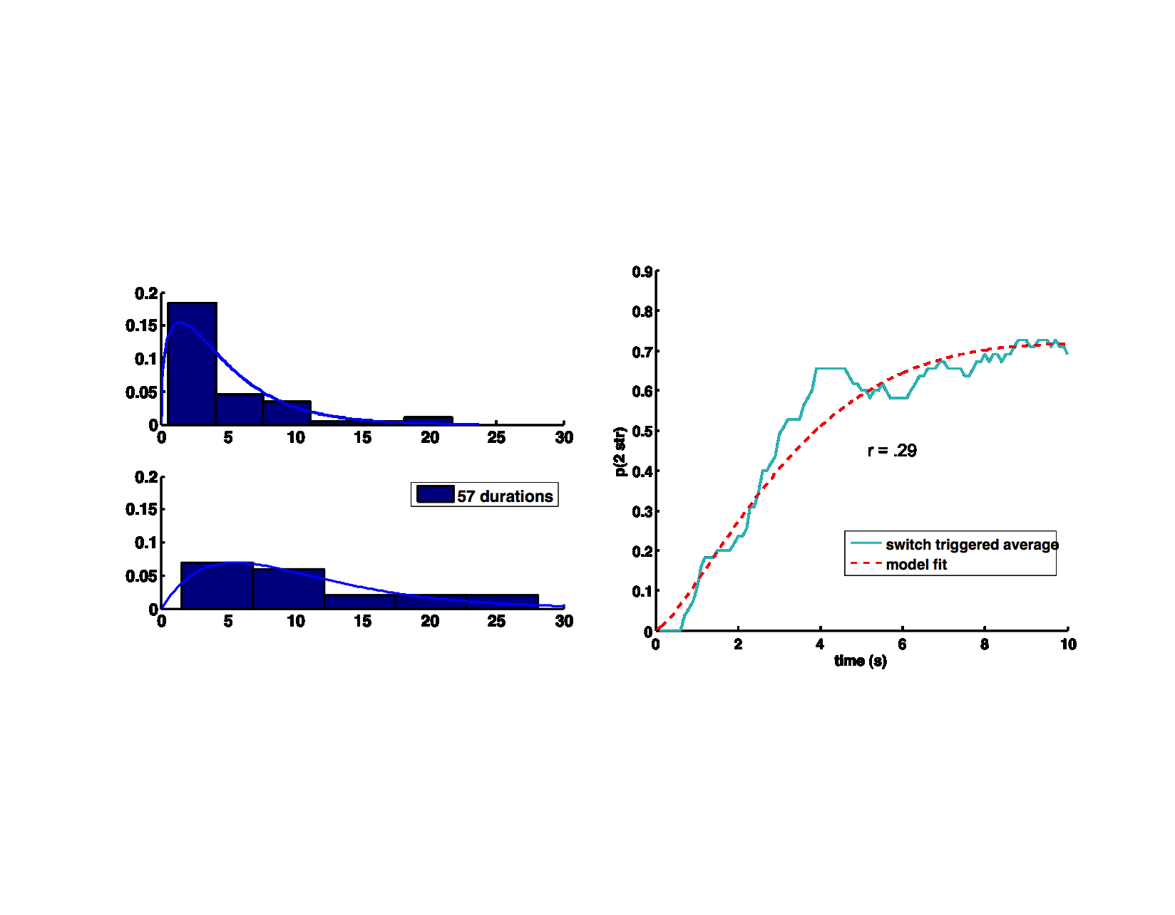

COMPETITION MODEL
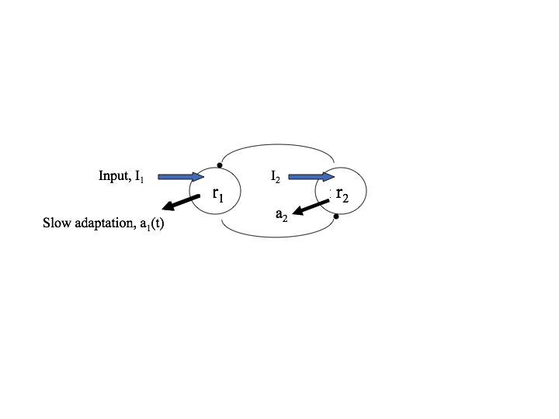
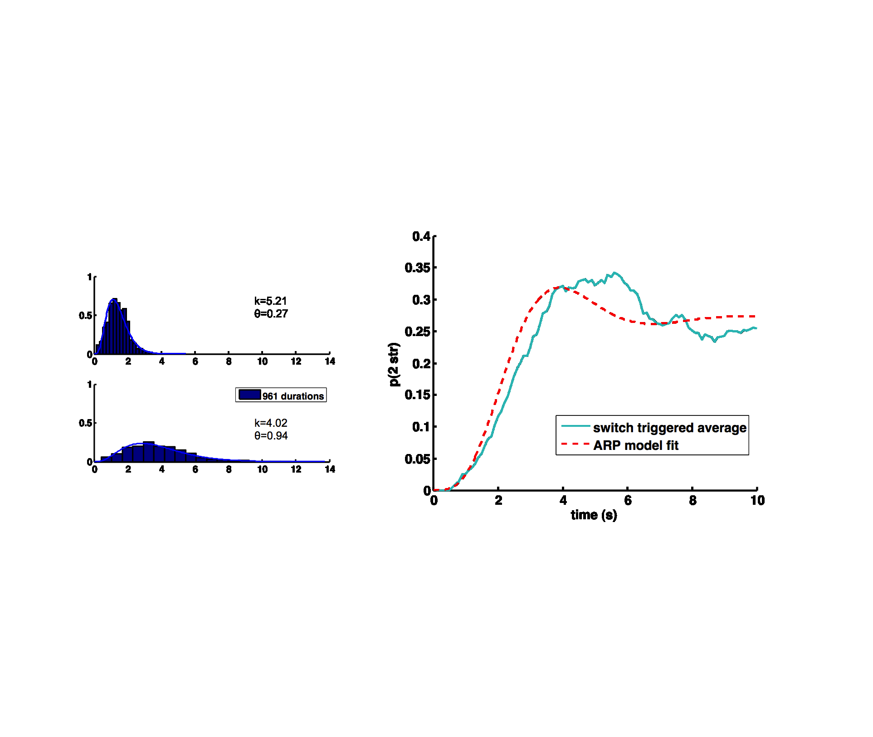
- Feedforward architecture explains coh-->seg, but not alternations

- Require competition between neural populations to achieve alternations
ARP model provides good fit to both experimental and mechanistically simulated data
- Buildup is an inevitable consequence of alternation when a particular state lawfully occurs first
- Buildup can be described without any mechanism of accumulation

